Aura Inventory

Product INVENTORY
Management System

Presented by
Leader: Nandhika S
Team members:
Deepika J
Hinduja N
Saipooja K
Yogya Priya N V
Project Overview:
Aura Inventory is a backend-focused web application developed using Node.js, Express.js, and MongoDB. It provides a secure and scalable solution for managing product data through RESTful APIs.
The system provides robust security by allowing users to create accounts and log in through JWT-based authentication, which ensures that only authorized individuals can access protected routes and perform operations. A core feature of the system is its complete CRUD functionality, enabling users to seamlessly add new products, view their specific inventory, update details like price or quantity, and delete items as needed. The backend is structured using the MVC (Models, Controllers, Routes) pattern, which helps maintain a clean and scalable codebase.

Key Objectives:
* Provide secure user authentication and authorization.
* Enable efficient inventory management through RESTful CRUD (Create, Read, Update, Delete) operations.
* Ensure user-specific data isolation so each user manages only their own products.
* Deliver fast, reliable API responses with proper validation and error handling.

Technical Architecture:
Aura Inventory uses a three-tier backend structure following the MVC (Models, Controllers, Routes) pattern.

* Backend: Node.js + Express.js.
* Database: MongoDB with Mongoose ODM for schema modeling.
* Authentication: JWT (JSON Web Tokens) with bcryptjs for password hashing.

Database Schema:
* Users Collection: Stores name, email (unique), and hashed password.
* Products Collection: Stores name, price, quantity, description, and a userId reference to link products to their owners.

Features and Functionalities:
* User Authentication: Secure register and login system using JWT.
* Product CRUD: Full capability to add, view, update, and delete products.
* Private Data Access: Users can only access and modify products they created.
* Product Search: Ability to filter and search products by name.

Project Setup:

1. Prerequisites:
* Node.js (JavaScript runtime).
* MongoDB (Database storage).
* npm (Package manager).
* VS Code (Development environment).
2. Installation:
Initialize the project and install required dependencies:
npm init -y
npm install express mongoose cors dotenv jsonwebtoken bcryptjs

3. Environment Configuration:
Create a .env file in the root directory:
PORT=5000
MONGO_URI=your_mongodb_connection_string

API Endpoints:

Authentication APIs:
* Register User: Validates input and creates a new account with a hashed password.
* Login User: Verifies credentials and returns a JWT token for protected access.

Product Inventory APIs:
* Create Product: Adds a new item to the user's inventory.
* Get All Products: Fetches only the products belonging to the logged-in user.
* Update Product: Modifies details of an existing product after verifying ownership.
* Delete Product: Permanently removes a product, protected by owner verification.
* Search Products: Filters inventory based on a keyword.

Execution:
2To start the Aura Inventory server, run the following command in the terminal:
npm start

The console should display: Server running on PORT and Database Connected.

Register:
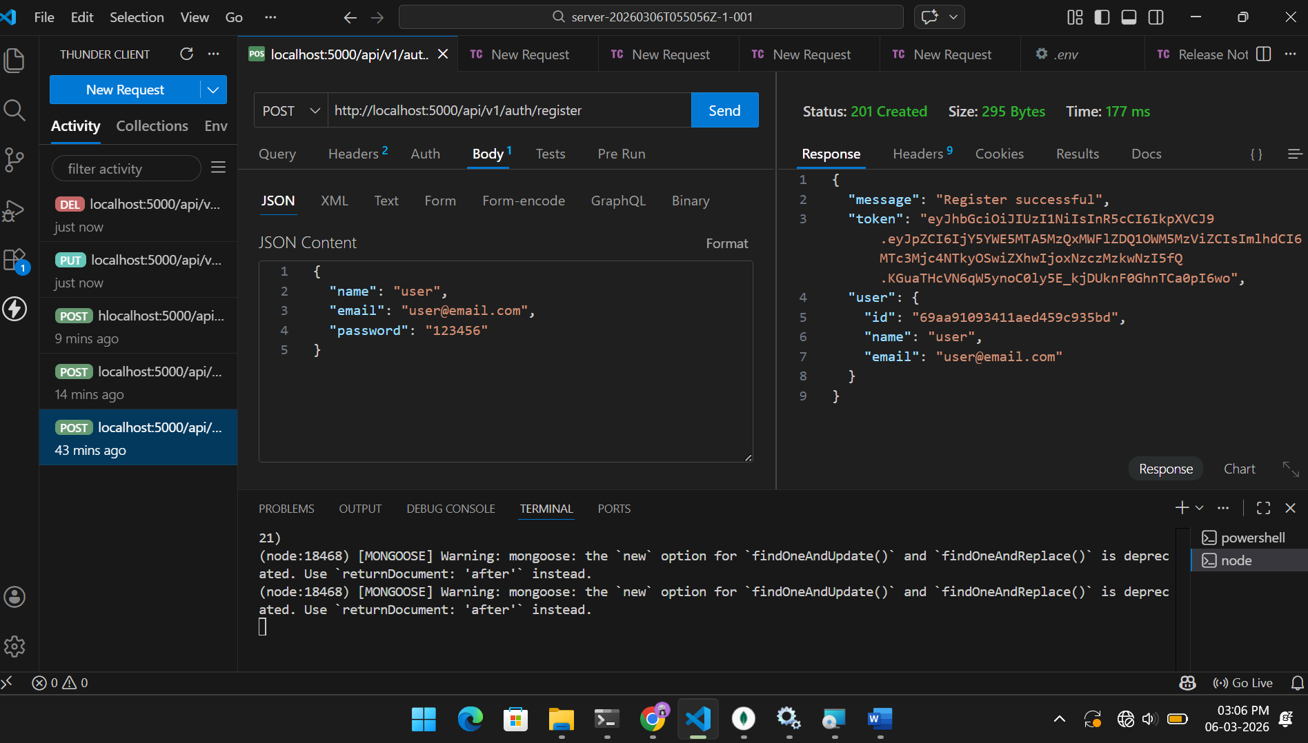
Login:
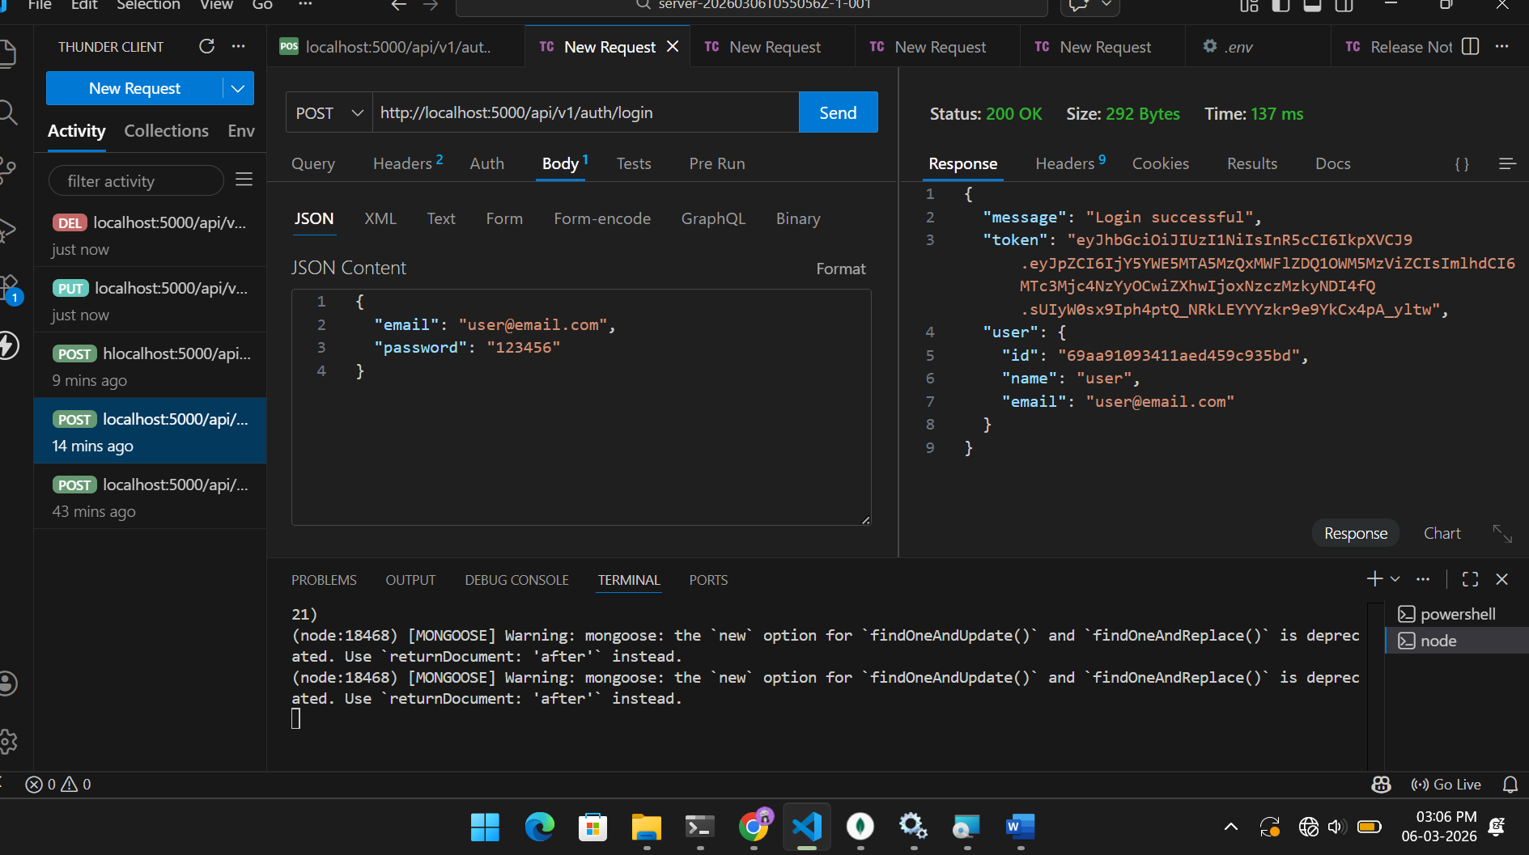

Create product:
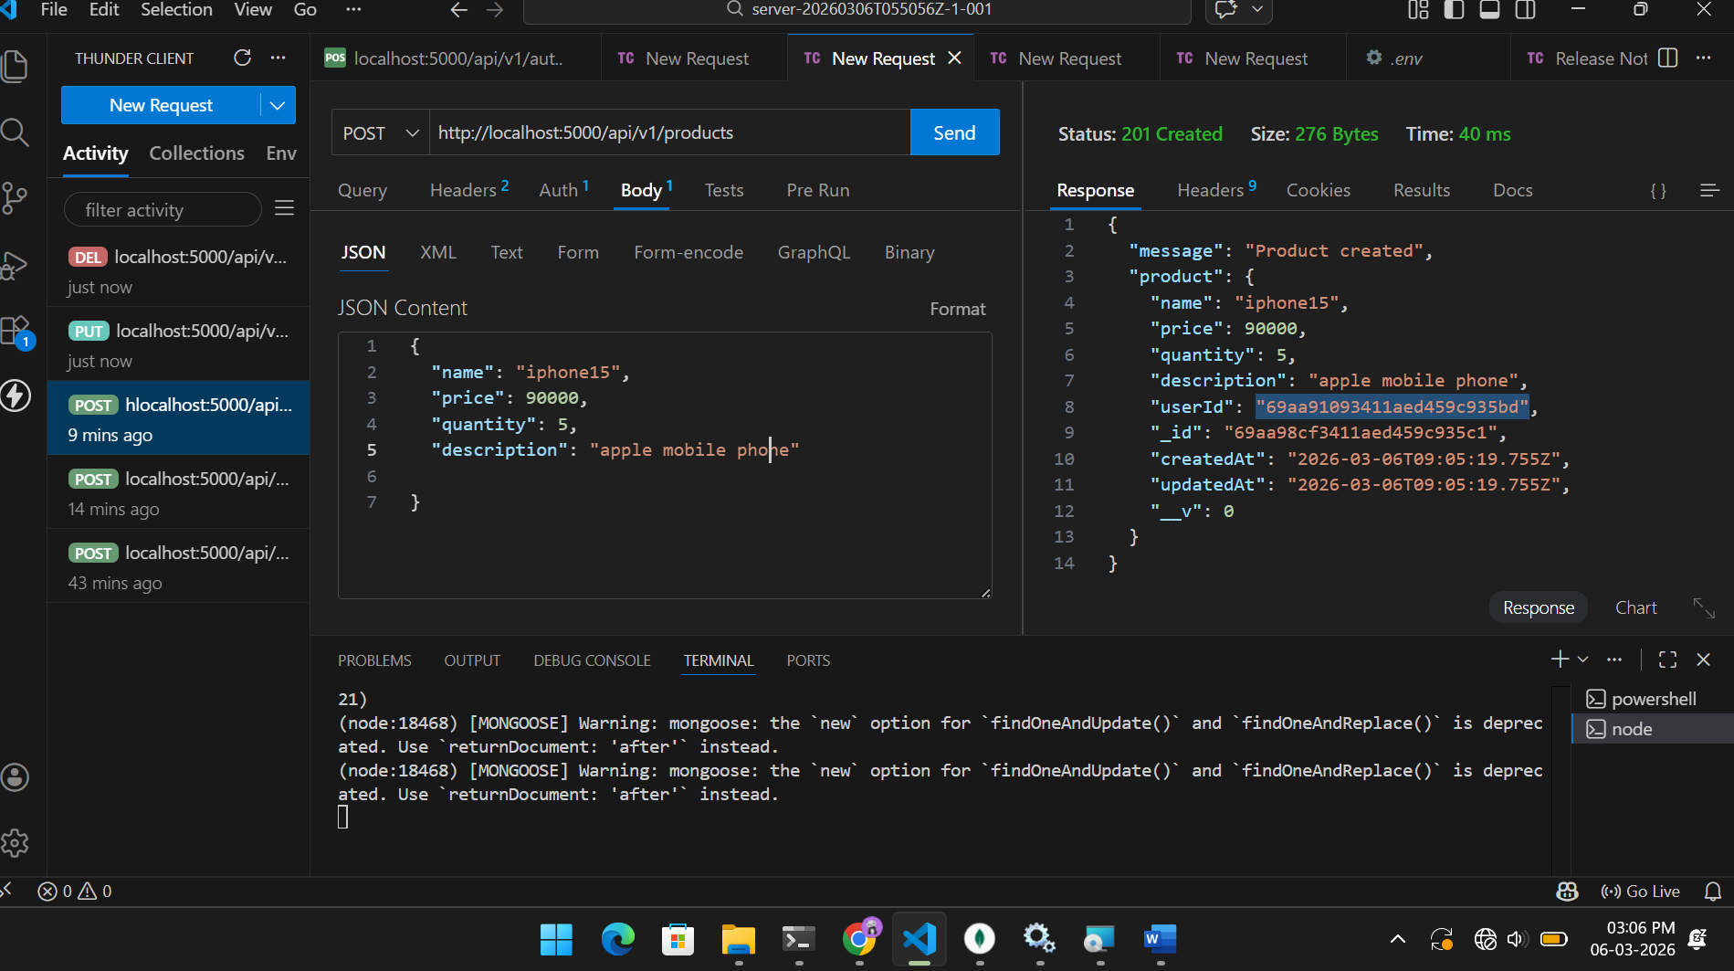

Updated product:
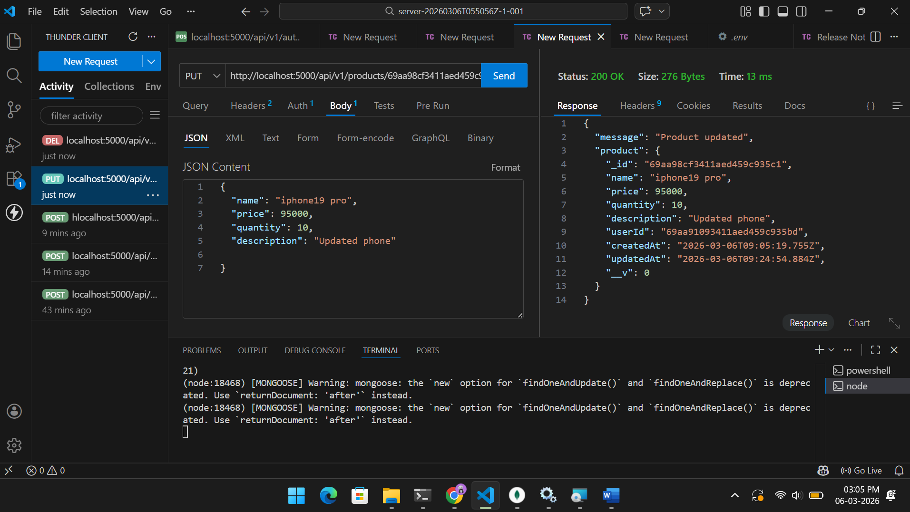

Product deleted:
